PREMIER SCREENING OF NOUN (Iraqi-Swiss documentary, 25 minutes, with English subtitles) AND SHAHEEDO TUM KAHAN HO (Pakistani documentary, 27 minutes, with English subtitles)

NOUN(Iraqi-Swissdocumentary, 25 minutes, with English subtitles)

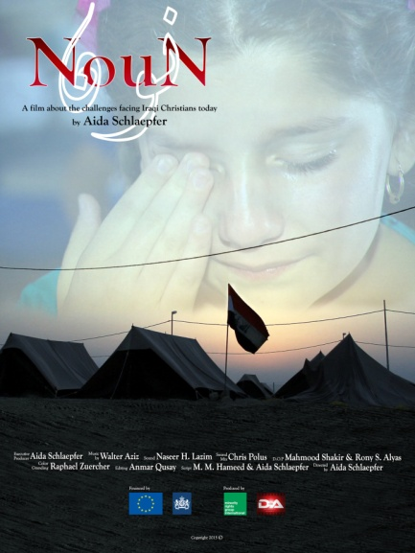

Director: Aida Schlaepfer
Producer: Minority Rights Group International & DA Production
Trailer: https://www.youtube.com/watch?v=NIUZdLnpxHw

“N”is the first letter of the Arabic word for Christian, “Nasrani” or Nazarene. The militants of Islamic State (ISIS) marked with a spray-painted “N” all Christian property – just like in this documentary. The film “Noun” depicts the suffering of Christian Iraqis at the hands of ISIS. It contains first-hand accounts of terrible atrocities, while revealing the courage of survivors, as well as their hopes and uncertainties about the future. The film has been accepted to several film festivals such as Festival International d'oran du Film Arabe, Alexandria Mediterraean Countries Film Festival, FilmTage Luzern and will be aired on television in several European countries.

About the director: Aida Schlaepferwas born in Baghdad to a Lebanese mother and an Iraqi father, and spent her childhood living between her parents’ homelands. At age 20, she moved to Europe, and eventually settled down in Switzerland. Aida credits her personal experience of having watched Lebanon and Iraq descend into warand anarchy with instilling within her a deep understanding of how destructive war is—both physically and psychologically.

SHAHEEDO TUM KAHAN HO(Pakistani documentary, 27 minutes, with English subtitles)

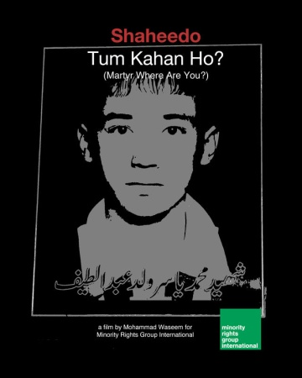

Director: Mohammad Waseem
Producer: Minority Rights Group International
Trailer: https://www.youtube.com/watch?v=GSP-1k-pcGI
„Shaheedo tum kahan ho?”, or „Martyr,where are you?” – asks the fim director. This interview-based documentary weaves a comparison between the violent discrimination against the Hazara and the problems faced by couples in inter-sect marriages. References to Sufi poetry, dance and ideology delineate the philosophy of love and tolerance from the extremism which is currently rampant in some sectors of Pakistani society.

About the director:The mission of Mohammad Waseemthrough his films isto put forward an alternative narrative of Pakistan against extremism. The Pakistani director living in his homeland has over 20 years of professional experience in art based activism for the promotion of peace, human and democracy.

